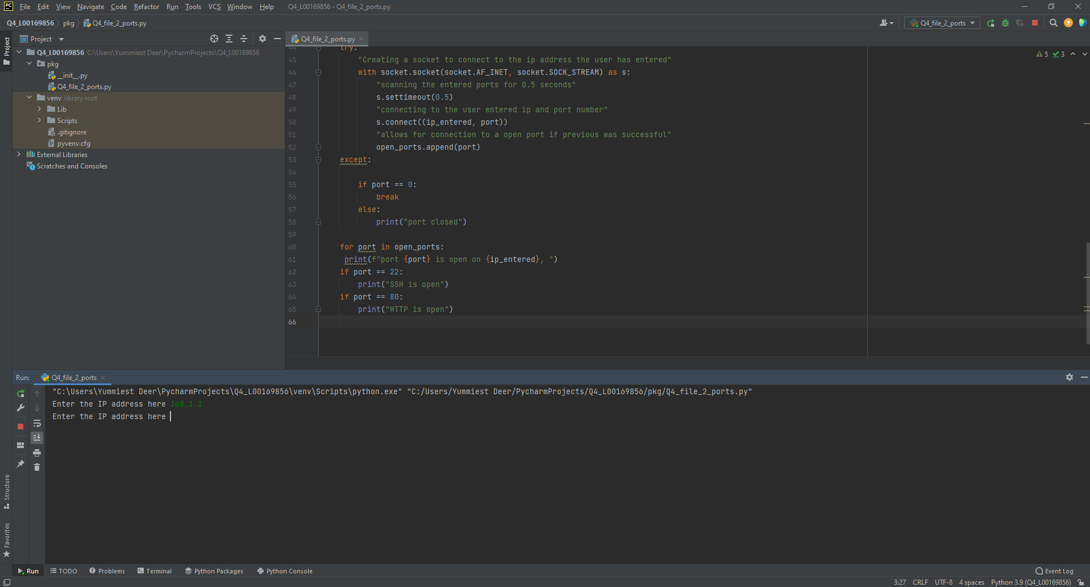

Script not accepting a non-valid IP address

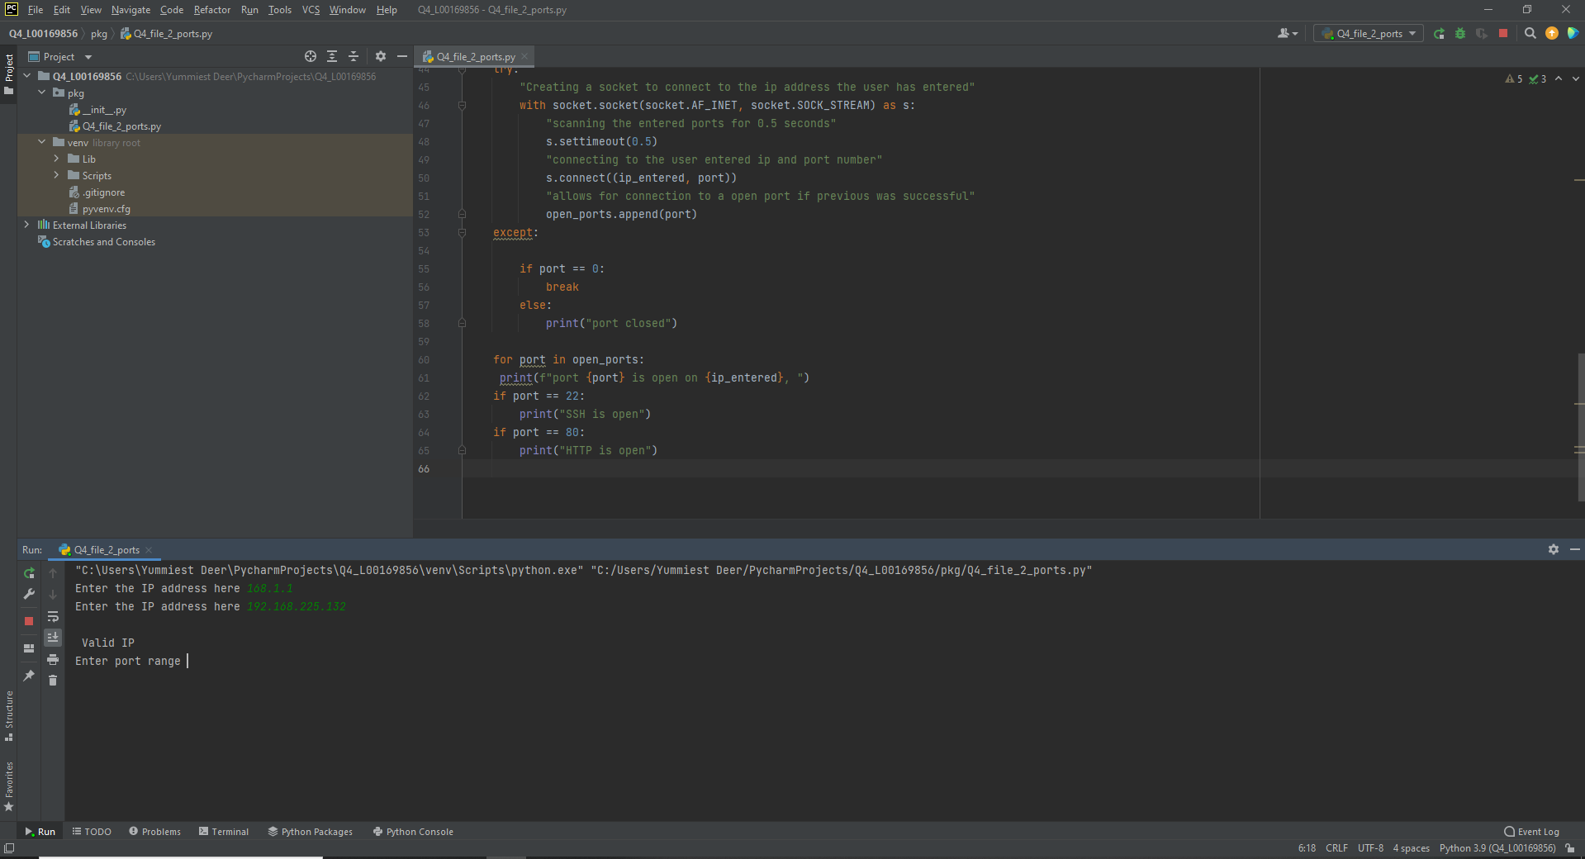

Alerting the user that a Valid IP address has been entered

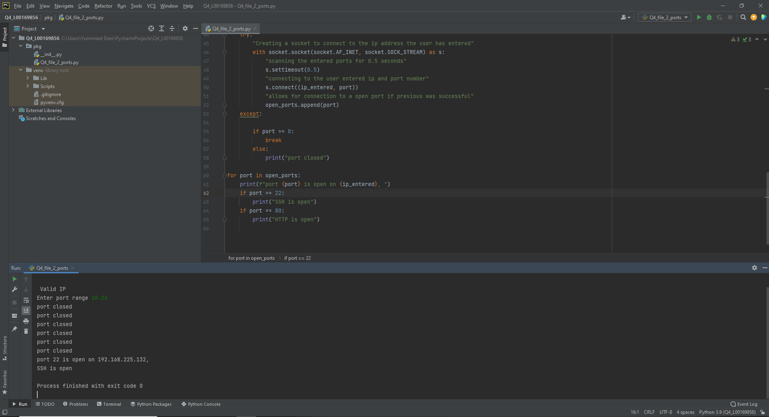

Port 22 open and showing message that its SSH

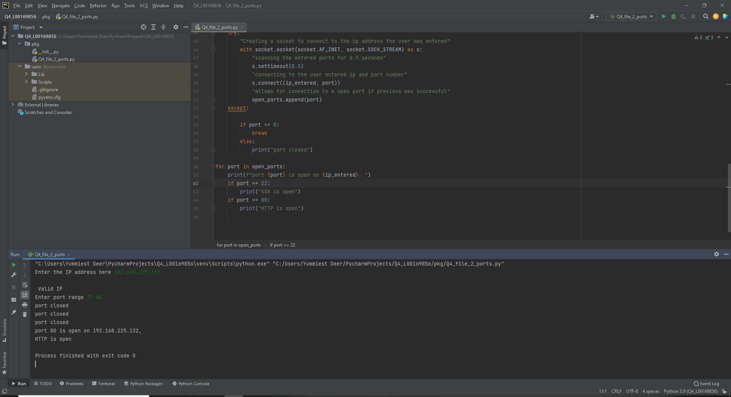

Port 80 open and being shown as HTTP